

October 2017

**We are captivated by events in which small, ordinary actions produce extraordinary results.** In the financial world, this delight and wonder is often directed toward compounding, the way invested money can seemingly multiply itself. But sometimes we are so intrigued by the extraordinary aspects of compounding that we overlook the ordinary actions that are essential.

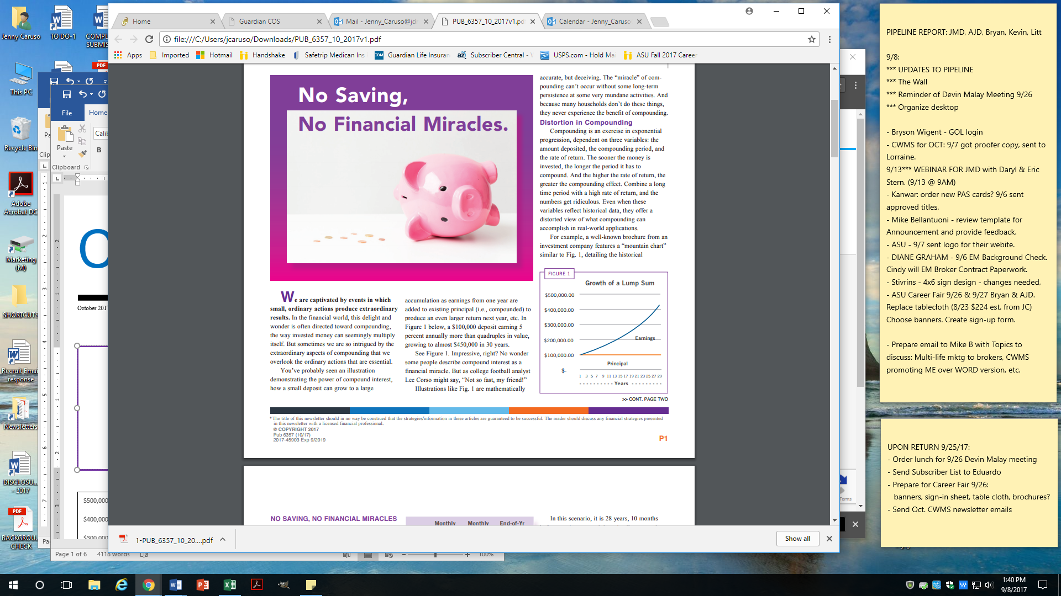

You’ve probably seen an illustration demonstrating the power of compound interest, how a small deposit can grow to a large accumulation as earnings from one year are added to existing principal (i.e., compounded) to produce an even larger return next year, etc. In Figure 1, a $100,000 deposit earning 5% annually more than quadruples in value, growing to almost $450,000 in 30 years.



**In This Issue…**

**NO SAVING,   
NO FINANCIAL MIRACLES**

**Page 1**

**AN ALL-PRO PERSPECTIVE  
ON FINANCIAL PROTECTION**

**Page 3**

**SOCIAL SECURITY:   
STILL HERE, STILL UNRESOLVED**

**Page 4**

**IS INVESTMENT RISK NECESSARY?**

**Page 5**

* The title of this newsletter should in no way be construed that the strategies/information in these articles are guaranteed to be successful. The reader should discuss any financial strategies presented in this newsletter with a licensed financial professional.

See Figure 1. Impressive, right? No wonder some people describe compound interest as a financial miracle. But as college football analyst Lee Corso might say, “Not so fast, my friend!”

Illustrations like Fig. 1 are mathematically accurate, but deceiving. The “miracle” of com-pounding can’t occur without some long-term persistence at some very mundane activities. And because many households don’t do these things, they never experience the benefit of compounding.

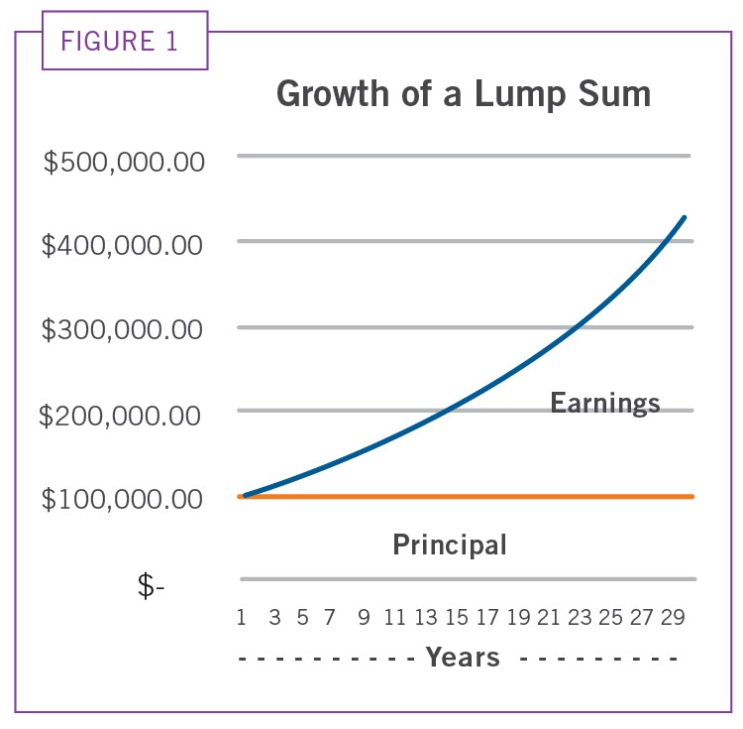

**Distortion in Compounding**

Compounding is an exercise in exponential progression, dependent on three variables: the amount deposited, the compounding period, and the rate of return. The sooner the money is invested, the longer the period it has to compound. And the higher the rate of return, the greater the compounding effect. Combine a long time period with a high rate of return, and the numbers get ridiculous. Even when these variables reflect historical data, they offer a distorted view of what compounding can accomplish in real-world applications.

For example, a well-known brochure from an investment company features a “mountain chart” similar to Fig. 1, detailing the historical performance of one of its

products. In their example, $10,000 invested at the beginning of 1934 would have grown to $123,437,514 by the end of 2016. That is not a typo. Compounding took $10,000 and made it $123 million. These numbers are mind-boggling, accurate – and also perhaps impossible to replicate, because every variable has been optimized for maximum compounding.

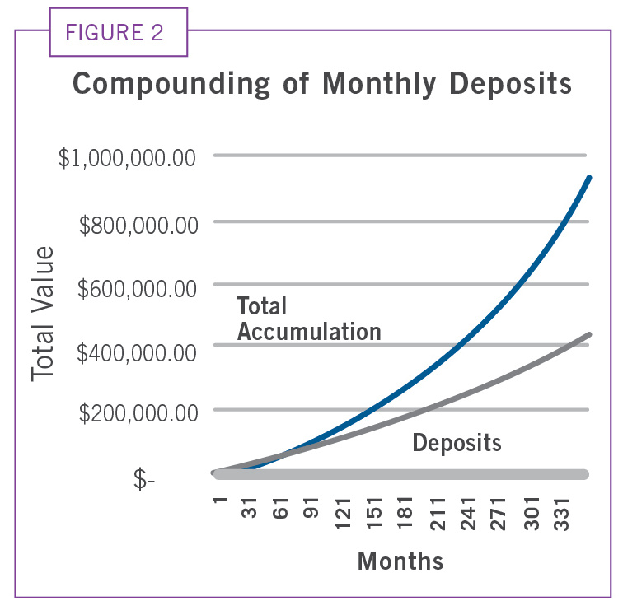

**FIG. 2**

First, the funding is up-front. Many compounding illustrations start with a significant lump-sum (adjusted for inflation, the $10,000 deposited in 1934 would be equivalent to $183,000 today). A large initial deposit maximizes potential compounding because all of the money is compounding from Day One. But if you’re just beginning to accumulate, it is more likely that your funding will consist of monthly deposits over many years, not a chunk of money at the start.

Second, the 12% annual rate of return may be historically accurate, but probably not representative of what an individual would achieve. Notes accompanying the illustration tell you that “results shown are before taxes on fund distributions and sale of fund shares.” It’s understandable that a brochure for public distribution can’t calculate individual tax costs, but taxes reduce real rates of return – for everyone.

Third, and perhaps most significant, the compounding occurs over an exceptionally long time. This illustration features an 83-year investment period in which the money has remained untouched, unspent. But who compounds for 83 years? Certainly not someone who hopes to enjoy the money during their lifetime.

While this example is historically accurate, it is not a scenario that individuals can use as a guide or benchmark.

**What Real-Life Compounding Looks Like**

Let’s construct a compounding scenario that might be closer to real-life.

We’ll start with a 35-year-old, earning $4,000/mo. who commits to saving 20% of income, or $800/mo.

On January 1st for the next 30 years, this individual receives a 3% raise (which matches the long-term average, per a recent study from the Federal Reserve), and increases his savings accordingly.

These deposits will compound monthly at a 5% annual rate of return. Under current market conditions, this reflects a reasonable net rate of return (in the mountain chart example, the rate of return for the past 10 years was 5.75% – before taxes). In some ways 5% is extraordinary, because the return does not fluctuate for 360 months.

Here’s what this projection looks like at several benchmark years:

**Monthly Monthly End-of-Yr**

**Income Saving Balance**

**Yr 1 $4,000 $800 $9,864**

**Yr 10 $5,067 $1,013 $140,228**

**Yr 20 $6,809 $1,361 $415,293**

**Yr 30 $9,151 $1,830 $931,723**

Our diligent long-term saver reaches the end of 30 years with just a bit under $1 million in total accumulation. Remember, that’s saving 20% of an annually increasing income every month for 30 years. Figure 2 illustrates the compounding progression. The blue line is the total accumulation, while the gray line represents total deposits.

Note the differences in the graphs. In Fig. 2, a much larger percentage of the compounding is comprised of deposits. In the early years, the difference between deposits and total accumulation due to compounding is minimal. It isn’t until the last 10 years that the separation gets dramatic. Here’s a breakdown of the percentage of savings and earnings at each 10-year milestone:

**% Saving % Earning**

**Yr 10 78 22**

**Yr 20 61 39**

**Yr 30 48 52**

In this scenario, it is 28 years, 10 months before earnings exceed deposits. For a very long time, the bulk of growth in the account comes from additional deposits, not compounded earnings. (At higher rates of return, the cross-over comes earlier, but even with a 7% rate of return, the earnings don’t surpass deposits until the 20th year.)

This is the reality of compounding: **The “miracle” requires a large pile of savings to remain untouched for a long period of time.** It’s not only getting the money invested, it’s being able to keep it invested. In a 30-year compounding scenario, the “take-off phase” of compounding, in which annual increases multiply rapidly, doesn’t occur until the end, which will likely be the last five or ten years before retirement. And then, instead of more compounding, withdrawals begin.

Compounding illustrations imply that time and rate of return can do all the work, turning small investments into fortunes. The math might “prove” this can happen, but **the essential ingredient for a compounding miracle is robust saving.** In real life, you simply don’t have time for compounding to make up for under-saving.



**The sooner you save,   
the better your chances  
 of receiving a   
compounding miracle   
later in life.**

**F**ive years ago, Kirk Cousins was selected by the Washington Redskins in the National Football League’s draft of college players, with the idea that he would serve as a back-up to starting quarterback Robert Griffin III. Here were the annual salaries in his four-year contract:



**An All-Pro Perspective on  
  
Financial**

**2012: $390,000**

**2013: $480,000**

**2014: $570,000**

**2015: $660,000**

In 2012, Cousins filled in for an injured Griffin in two games, including the last game of the season. As Griffin continued to struggle with injuries the following season, Cousins’ playing time increased. Then, with a coaching change after the 2014 season, Cousins was named the full-time starter for 2015.

Cousins performed well, setting several team records while leading Washington to the playoffs. His success created a dilemma for team management: Cousins’ contract had expired, and the team had to decide if he should be offered a new contract, and whether that contract should reflect his status as a starter, or just a capable back-up. But if Washington offered contract terms for a back-up quarterback, Cousins would probably sign with another team who was willing to pay him (and play him) as a starter.

A provision in the NFL’s bargaining agreement says a team can retain a player’s services for an additional year, provided the player’s compensation increases to an amount equal to the average of the highest salaries at the position. Not sure if Cousins was their man, but not wanting to let him go to another team without a suitable replacement, Washington management decided to use this option, known as the “franchise” designation.

As a result, Cousins was paid $19,953,000 in 2016. After earning less than $2 million over the past four years, he received almost $20 million for one year, just so the team could postpone a decision on offering him a multi-year contract.

Once again, Cousins performed well. And once again, Washington management was faced with the same decision: Should Cousins receive a long-term contract? After some half-hearted negotiations, management again decided to exercise their franchise option. For the 2017 season, Cousins will be paid $23,943,000.

Because professional football is a brief, high-risk occupation, good players have a strong incentive to seek long-term contracts, particularly those with guarantees. While Cousins will have earned almost $44 million from his two one-year contracts, and has the chance to receive a hugepayoff next year as a free agent, he currently has no job security.

Or does he? Here’s ESPNs’ Dan Graziano, from an August 6, 2017, report:

**Protection**

In case you were wondering, no, Kirk Cousins isn't worried. About anything.

Having let the July 17 deadline pass without signing a long-term deal, Washington’s quarterback isn't worried about what might happen. Not worried about a career-altering injury that scuttles his free-agent prospects. Not worried about having a down year. Not worried about the other big names that might join him on next spring's free-agent quarterback market.

Cousins said his decision not to sign a long-term deal with Washington came down to one basic thing: He didn't feel right about signing.

“I didn't feel at peace with signing a long-term deal at this juncture,” Cousins said after the team's morning walk-through at training camp here Sunday. “I think the freedom that it allows on the other side of this season makes more sense. In the league, there's so much change, so much turnover year after year, I think it makes a lot of sense to re-evaluate where we're at, where the league's at, at the end of this season.”

“That was reason No. 1, and there's other ways you can protect yourself, through insurance policies and things like that, where you have answers if the worst does happen.”

**An All-Pro Perspective on Financial Protection**

Among NFL players, Cousins’ embrace of insurance is not the norm. Chris Larcheveque, an executive vice president of an insurance company authorized by Lloyd's of London to underwrite disability insurance policies for professional athletes, estimates that only about 40% of NFL players have individual coverage.

The NFL does provide limited disability coverage that offers benefits of about $180,000 after taxes. That might sound like a lot of money, but for someone making $2 million a year (the average NFL salary) those numbers don’t come close to protecting their earning potential. And if you’re making $20 million? $180,000 is less than 1% of earnings. Yet Larcheveque says many players just don’t want to pay the premiums for individual protection.

“A lot of guys who need it are rookies, and they don't want to spend $20,000, $30,000 or $40,000 on insurance. It's a big chunk of money on something that is a safety net.”

Besides insurance protection, Cousins is also a savings fanatic. When other first-year players bought new cars from their first paychecks or signing bonuses, Cousins continued to drive a dented minivan previously owned by his grandparents. “Maybe someday I’ll have enough saved and I’ll see what I can get,” he told the *Wall Street Journal* in a January 2016 article. “But it’s better to buy appreciating assets than depreciating. No yachts, no sports cars. You don’t know how long you’re going to play, you’ve got to save every dollar even though you are making a good salary,” he continued. “You never know what’s going to happen so I try to put as much money away as I can.”

Again, Cousins is a financial outlier amongst his athletic peers. A 2015 study found that about one out of every six NFL players drafted between 1996 and 2003 filed for bankruptcy protection within 12 years of retirement. These financial troubles weren’t limited to low-paid players or those who had brief careers. “Bankruptcy rates are not affected by a player's total earnings or career length,” a summary of that study noted. “Having played for a long time and been well-paid does not provide much protection against the risk of going bankrupt.”

**Because of his “protection-first” approach (using insurance and savings), Cousins is comfortable with the risk of playing under another one-year contract in order to pursue better opportunities in 2018. As far as he’s concerned, he has “answers if the worst does happen.”**

**An insurance professional couldn’t have dreamed of a better real-life example of how good risk management strategies make risk-taking practical. ❖**



**Social Security:**

**Still Here, Still Unresolved.**

**T**hirty-five years ago, a financial professional having an introductory discussion with a customer might ask: “Do you think you can count on Social Security still being around when you retire?” Quite often, the answer was “no.” It was common knowledge that Social Security was under-funded, and destined to go broke.

Today, the question remains relevant, because Social Security is still destined to go broke. While some alterations in the mid-1980s averted the imminent collapse of Social Security, these changes only postponed the actuarial issues that must be addressed to ensure the program stays solvent.

**The Facts**

Social Security is a pay-as-you-go program. Annual revenues (from payroll taxes, income taxes, and interest earned on reserves held in a trust fund) are used to pay old-age and survivor benefits to eligible retirees. Even though individual workers earn credits today that determine their future retirement checks, their payroll taxes are not set aside to fund their benefits. The payroll taxes from today’s workers are used to pay for today’s retirees.

As the Baby Boomer generation ages, this influx of retirees has put Social Security at a tipping point; in several years, benefits paid have exceeded revenues collected. In the past, these deficits have been covered by accumulated reserves held in a trust fund. In their 2016 annual report, trustees for Social Security projected break-even status through 2019. But beyond this point, the imbalance between workers and retirees is expected to increase. Benefits will continually and significantly exceed revenues, resulting in a gradual decline and eventual exhaustion of all reserves by 2034. In simple terms, Social Security will be broke.

But contrary to common understanding, benefits would not stop when the Social Security trust fund is gone. At that point, Social Security would continue using its annual tax income to make reduced payments, which recipients would share on an equal basis. According to the latest trustees’ report, these revenues would be sufficient to allow the program to pay 79% of the program's benefits. Thus, a retiree receiving $1,000/mo. from Social Security would see a reduction to $790/mo.



**The Possible Fixes**

Once benefit programs are established, many recipients come to consider them as permanent. Termination of a program, or austerity measures like paying three quarters of promised benefits is probably not politically feasible. Which means sometime before 2034 (and hopefully sooner than later), Congress will be compelled to take action to restore long-term solvency to Social Security.

Among the possible actions:

**Increase the payroll tax rate.** Since everyone participates in the plan, and everyone is eligible for benefits, the easiest way to resolve the funding issue is to increase taxes on everyone. This has the downside of inflicting a proportionally greater financial burden on lower-income Americans.

**Increase the amount of earnings subject to payroll tax.** Currently, income above $127,200 is not subject to Social Security withholding. Some proposals would remove this ceiling and make all income subject to payroll taxes.

**Increase the full retirement age to 70.** The current full retirement age is incrementally increasing to 67 for those born in 1960 or later. Participants are eligible to receive a pro-rated percentage of their full retirement benefit at age 62, so increasing the full retirement age would effectively decrease the percentage for those who choose to start benefits early.

**Decrease cost-of-living adjustments (COLA).** To keep pace with inflation, Congress has authorized regular increases in benefits based on the Consumer Price Index. COLA payments could be diminished, eliminated, or approved on a year-by-year basis.

**Implement a means-test to decrease or eliminate benefits** for those who have other retirement assets. Because they have other sources of retirement income, some   
individuals already pay income taxes on their Social Security

benefits. A more stringent standard could either reduce or eliminate payments for wealthier retirees, and divert these funds to less-fortunate retirees. But this approach goes against the philosophical ideal of Social Security, where everyone contributes to the program, and everyone receives a benefit.



**Do you think you can  
count on Social Security  
for retirement?**

**How to Plan for Social Security**

In a way, the same question applies: “Do you think you can count on Social Security for retirement?” Today’s realistic answer is: “Yes. But how much will it be worth?”

Politicians and economists like to think the course of Social Security can be corrected by tweaking the numbers – a better economy, different tax policy, adjusted retirement ages. But at the core, Social Security has a demographics problem. There are too many retirees and not enough workers to support them. Barring some cataclysmic event, those numbers aren’t going to change.

For those who are on track with their retirement planning and saving, preparing to live without it (either because of means-testing or reduced payouts) is prudent. Social Security can then be seen as a retirement “bonus” – whatever it pays is a happy addition, extra money that can be spent and enjoyed.

For those who haven’t made good progress on saving for a personally-funded retirement, the hope that Social Security is going to provide a substantial or reliable bail-out is less certain. Social Security may not go broke, but you can’t really depend on it for retirement security. ❖



**Is Investment Risk Necessary?**

**T**here is a school of thought among some financial professionals that says “To make money, you have to be willing to lose money,” by investing in volatile and non-guaranteed financial instruments, such as stocks, bonds, mutual funds, ETFs, limited partnerships, etc.

Adherents to this approach almost always point to historical, mathematical evidence. They have analyses that  
show which asset classes have kept pace with inflation, or which investments, despite their fluctuating values, have delivered superior average returns. For them, the numbers are clear: Investment risk is necessary. And done correctly, the results, while not guaranteed, have been better than “safer” alternatives.

This steady stream of mathematical “proof” has convinced a large segment of the American populace. As one financial professional puts it, “People take investment risk because the financial services industry has told them it’s safe to do so.”

But is this true? When you begin to integrate the human factors with the math, there’s a slightly different picture. There are risks not only from the nature of the investments, but also from investor behavior. It is because of this combination of unpredictable action, that Bob Seawright concludes in a Summer 2017 *Research on Wealth* article, “Investing successfully is really hard.”

**Asymmetric Returns, Consistent Volatility**

Returns from non-guaranteed asset classes are usually asymmetric. They do not occur consistently or in recognizable patterns, and profits or losses may be concentrated in particular asset classes at particular times. Even broad evaluations over longer time periods show this asymmetry; movement is sporadic, unpredictable. Look at the real growth of a dollar invested in the S & P 500 for the following periods:

**1929-43: $1.08**

**1944-64: $10.83**

**1965-81: $0.94**

**1982-99: $11.90**

**2000-present: $1.35**

Not only are returns asymmetrical, the winners are rare. Hendrik Bessembinder, a finance professor at Arizona State University, has compiled a database on the performance of nearly 26,000 stocks going back to 1926. Among his findings:

* **58% of all stocks underperformed one-month U.S. Treasury bills**, and a majority of these stocks lost money over their lifetimes. A Treasury bill (T-Bill) is a short-term debt obligation backed by the U.S. government with a maturity of less than one year. T-Bills are attractive to investors because they offer a very low-risk way to earn a guaranteed return on invested money. If the long-term performance of almost 60 percent of stock investments doesn’t match that of T-Bills, why take the risk?
* **A few big winners make the overall averages look good.** The historical proof that non-guaranteed assets out-perform other asset classes? Bassembinder finds that “The entire net gain in the U.S. stock market since 1926 is attributable to the best-performing four percent of listed stocks, as the other ninety six percent collectively matched one-month Treasury bills.”

While gains might be asymmetric, volatility is consistent. A February 2017 study by Ben Carlson found that between 1930 and 2016, almost half of those years featured moments where stocks experienced declines of 10% or more. These losses were often regained or exceeded in the course of a year, but the fluctuations are emotionally challenging. As Seawright says:

“Here’s an important corollary to my primary thesis: Even great investing is really hard to abide (because) even the best



possible portfolios suffer huge (and thus terrifying) drawdowns. Here is the bottom line: Perfect foresight demands great returns, but still demands gut-wrenching drawdowns. Even if we could hire God as our money manager and He always picked the top stocks in advance, most of us would still fire him for the drawdowns – many times over!”

**The Best Approach to Investment Risk**

This gets to the heart of the matter: Over long periods of time, returns from non-guaranteed asset classes may be historically superior – but only if investors maintain their positions. This is sometimes referred to as “perfect investor behavior,” the ability to ignore asymmetry and volatility in order to have the best possible chance of realizing the long-term potential from non-guaranteed asset classes.

This newsletter is prepared by an independent third party for distribution by your Representative(s). Material discussed is meant for general illustration and/or informational purposes only and it is not to be construed as tax, legal or investment advice. Although the information has been gathered from sources believed reliable, please note that individual situations can vary, therefore the information should be relied upon when coordinated with individual professional advice. Links to other sites are for your convenience in locating related information and services. The Representative(s) does not maintain these other sites and has no control over the organizations that maintain the sites or the information, products or services these organizations provide. The Representative(s) expressly disclaims any responsibility for the content, the accuracy of the information or the quality of products or services provided by the organizations that maintain these sites. The Representative(s) does not recommend or endorse these organizations or their products or services in any way. We have not reviewed or approved the above referenced publications nor recommend or endorse them in any way.   
*The title of this newsletter should in no way be construed that the strategies/information in these articles are guaranteed to be successful. The reader should discuss any financial strategies presented in this newsletter with a licensed financial professional.

**All investment contains risk and may lose value. Past performance is not a guarantee of future results.**

Lifetime Financial Growth is an Agency of The Guardian Life Insurance Company of America (Guardian), New York, NY. Securities products and advisory services offered through Park Avenue Securities LLC (PAS), member FINRA, SIPC. PAS is an indirect, wholly-owned subsidiary of Guardian. Lifetime Financial Growth is not an affiliate or subsidiary of PAS or Guardian. 2017-48061 EXP. 09/2019

If you are aware of the interplay between the characteristics of non-guaranteed assets and human behavior, you might arrive at these two conclusions about risk:

1. Better to save more, and take less risk. The driving idea behind taking risk is the need for investment returns to make up for a lack of saving. But if you figure out how to save more, you don't have to take those risks. Practically and psychologically, which approach is most effective?
2. Take investment risk because you can, not because you have to. The best chance of having perfect investor behavior is knowing you have enough savings to ride out the fluctuations, or afford a loss. If your financial situation sees investment risk as the only way to achieve your financial objectives, perfect investor behavior is unlikely – and so is success.

**In short, the best approach to investment risk is to become a world-class saver.** ❖